**Over Time**

Response Times Over Time -->歷時六分鐘 2500ms 下降至1500ms

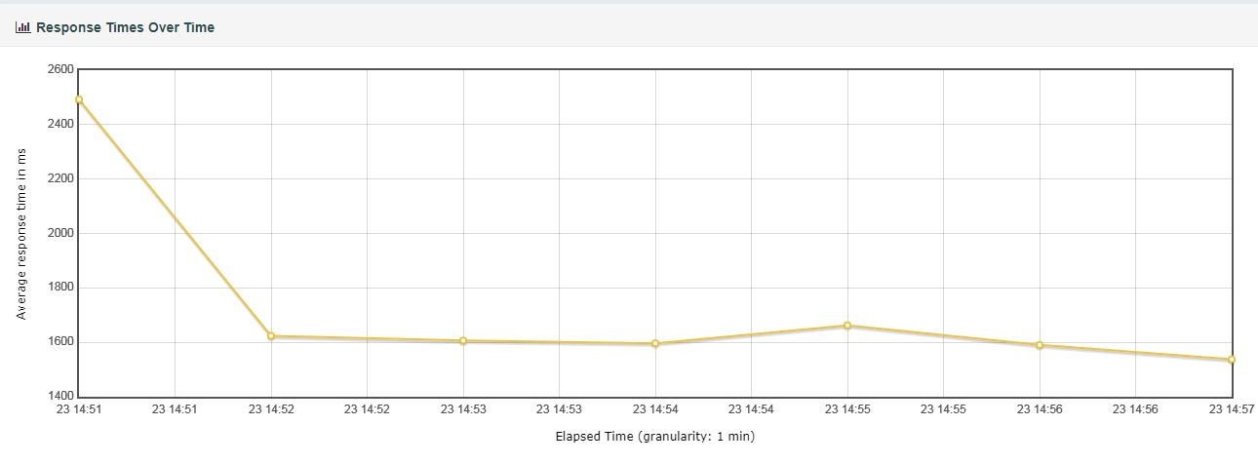

**Bytes Throughput Over Time:**

藍色為每秒發送Bytes 數 min 22378 bytes/s ,max 53237 bytes/s.

黃色為每秒接收Bytes 數 min 15860 bytes/s, max 22085 bytes/s.

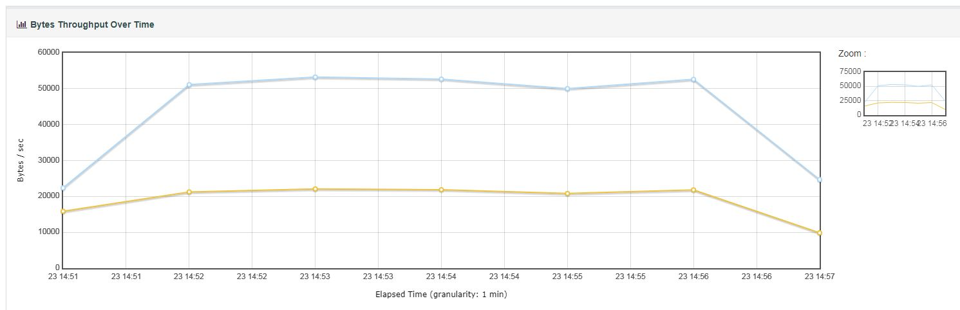

**Response Time Percentiles Over Time (successful responses)**

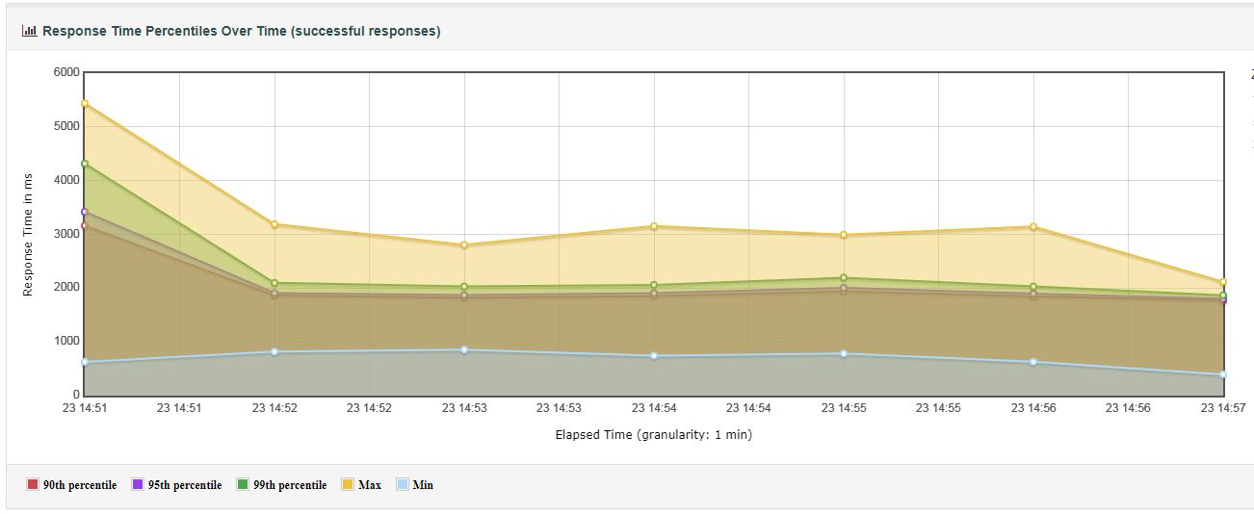

**Active Threads Over Time**

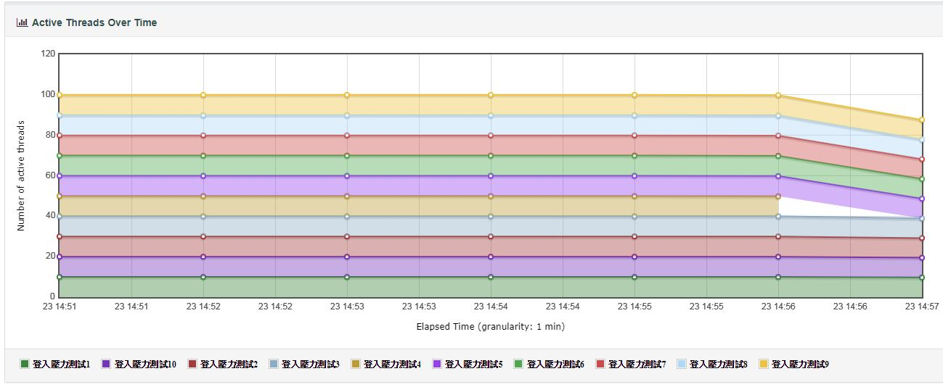

**Latencies Over Time**

收到從服務端返回的請求 Average latency

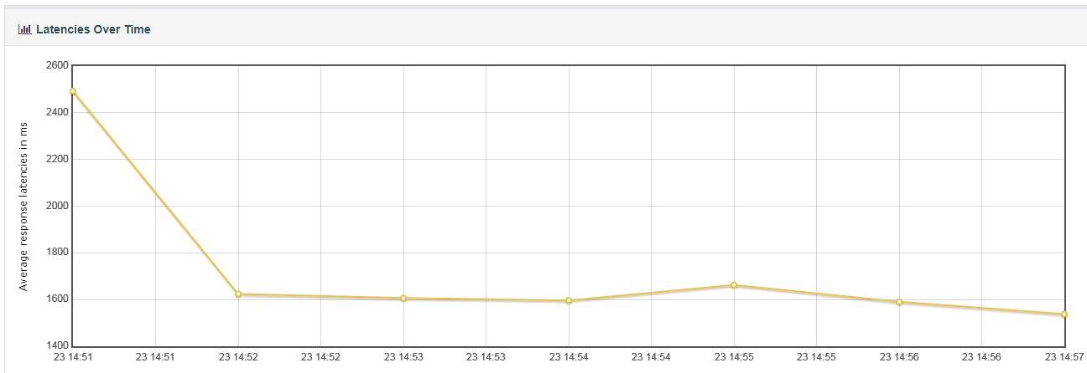

**Connect Time Over Time**

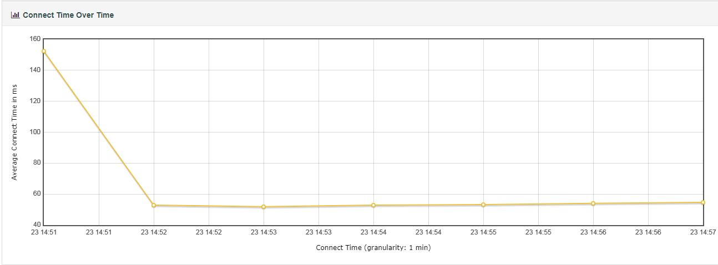

**Throughput 檔**

hits per second:每秒點擊率

code per second:每秒狀態碼數量

Transaction per second:每秒交易量 max 58 transactions/s

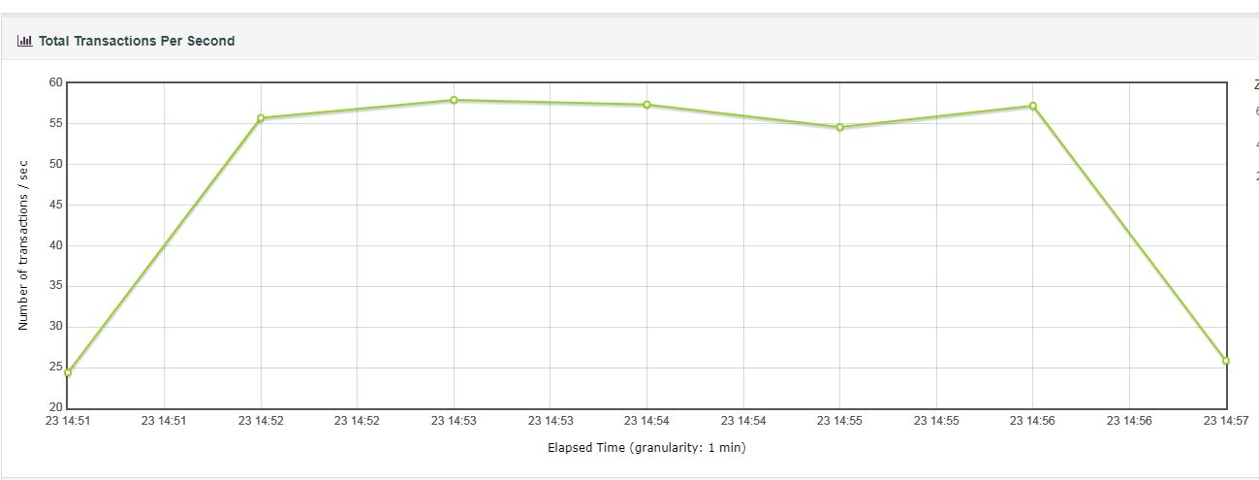  
Response Time Request:響應時間點的請求的 成功/失敗 數

Latency Vs Request: Delay time point request success/ failed.

**Response Times 檔**

Response Time Percentiles 響應時間百分比

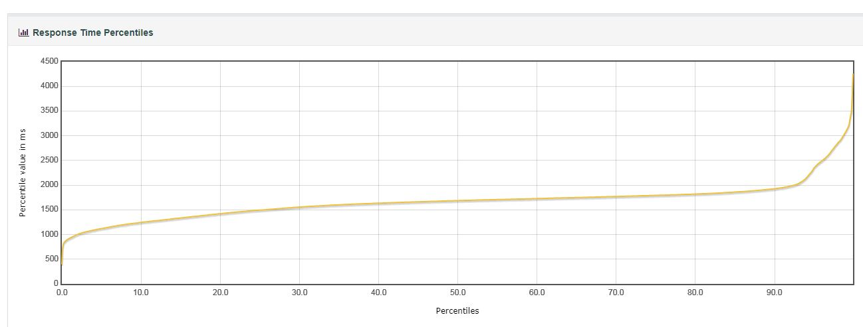

**Response Time Overview**

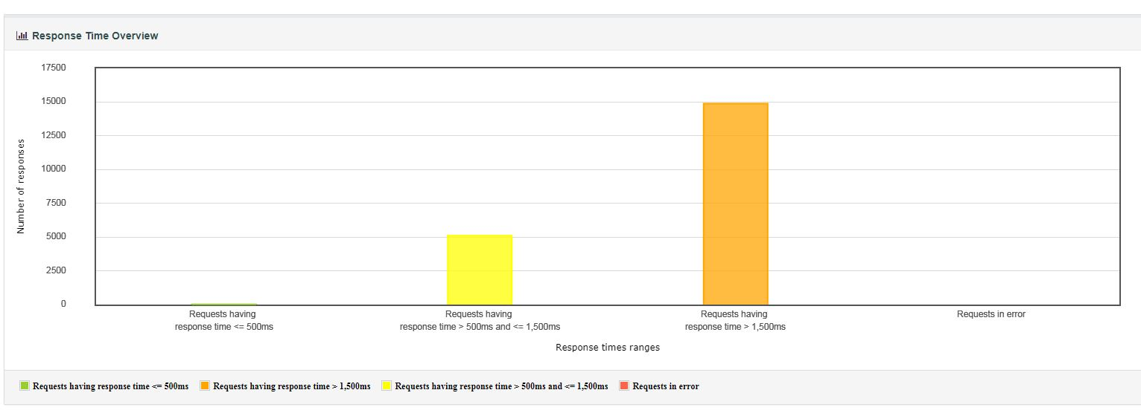

**Time vs Threads:測試過程中的線程時數**

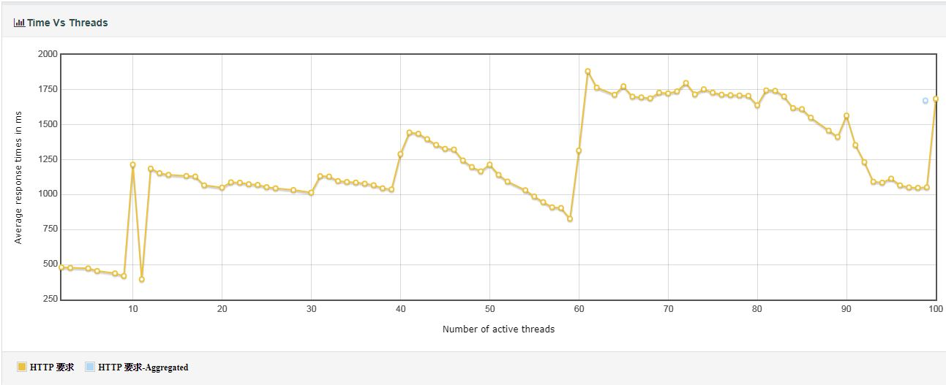.

**Response Time Distribution響應時間分布**

